**Understanding the SQL language and ‘Project’ Table London creation**

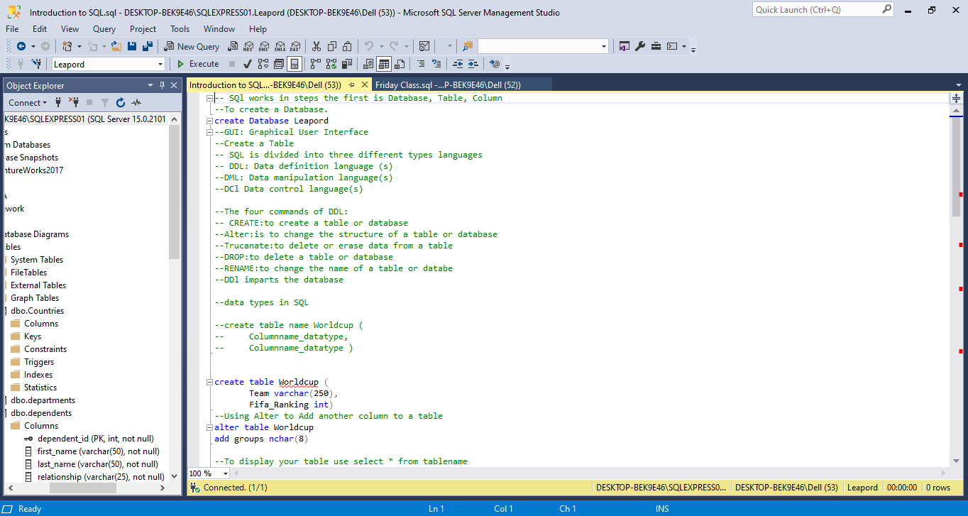

**Table ‘Project’ London and inserts in table ‘Production’ and a variety of function commands and this includes Create. | Insert. | Update. | Select *. | Count. | Max. | Min. |AVG.**

